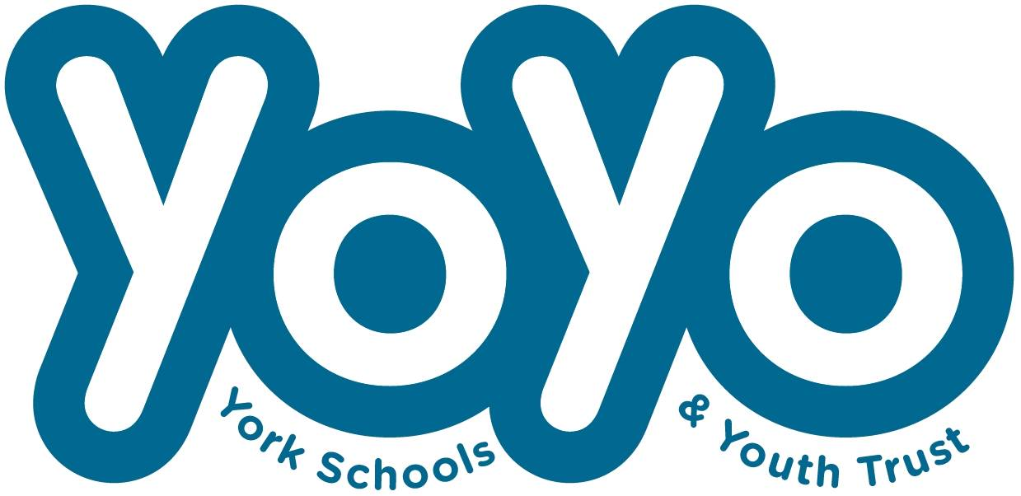 

Please treat as Gift Aid donations all qualifying gifts of money made:

🞏 today 🞏 in the past 4 years 🞏 in the future

Please tick all boxes you wish to apply.

I declare that I am a UK taxpayer and understand that if I pay less Income Tax and/or Capital Gains Tax than the amount of Gift Aid claimed on all my donations in that tax year it is my responsibility to pay any difference.

**Donor’s details:**

Title: ………………. First name(s): …………...……….………………………………………………...

Surname: ……………………………………….………………………………………………….……….

Full home address: ……………………….………………………………..……………………………...

…………….………………………………………. Postcode: …………………………………………..

Email address: …………………………………... Phone Number: ……………………………………

Date: ……………………………………………… Signature: …………………………………………..

**Donation details**: I will donate £…….. per month/week/one off.

**YoYo details:**

York Schools and Youth Trust Sort code: 30 99 99 Account number: 0133 0055

Email this form to us at: office@yoyotrust.org.uk or post to the address below.

***Please notify YoYo if you:***

* *want to cancel this declaration*
* *change your name or home address*
* *no longer pay enough tax on your income and/or capital gains to continue with GiftAid.*
* *If you pay Income Tax at the higher or additional rate and want to receive the additional tax relief due to you, you must include all your Gift Aid donations on your Self-Assessment tax return or ask HM Revenue and Customs to adjust your tax code.*

***Thank you for your support!***